Footer

Definition:
# Source: AI Source: Provided by: [Data Path: Persons Table -> ID Column: 1, Name_En Column: Motasem Essam] -> From: [Chatgpt (GPT‑5 Mini)] on [2/12/2026]
A Footer is the bottom section of a web page that usually appears on every page of a website and contains important information and links.

Simple Definition
# Source: AI Source: Provided by: [Data Path: Persons Table -> ID Column: 1, Name_En Column: Motasem Essam] -> From: [Chatgpt (GPT‑5 Mini)] on [2/12/2026]
Footer = the bottom part of a web page that provides site-wide information, links, and resources.

What a Footer Usually Includes
# Source: AI Source: Provided by: [Data Path: Persons Table -> ID Column: 1, Name_En Column: Motasem Essam] -> From: [Chatgpt (GPT‑5 Mini)] on [2/12/2026]
- Copyright information – © Year, Company Name
- Contact info – email, phone number, or address
- Quick links – About, Privacy Policy, Terms of Service
- Social media icons – Facebook, Twitter, LinkedIn, Instagram
- Newsletter signup (optional) – email subscription form
- Sitemap or secondary navigation (optional) – helps users explore the site

Purpose of a Footer
# Source: AI Source: Provided by: [Data Path: Persons Table -> ID Column: 1, Name_En Column: Motasem Essam] -> From: [Chatgpt (GPT‑5 Mini)] on [2/12/2026]
- Provide important information consistently across all pages
- Offer easy navigation to legal or informational pages
- Help users contact or connect with the business
- Enhance user experience and trust

Examples
# Source: AI Source: Provided by: [Data Path: Persons Table -> ID Column: 1, Name_En Column: Motasem Essam] -> From: [Chatgpt (GPT‑5 Mini)] on [2/12/2026]
- E-commerce site → links to shipping policy, return policy, social media
- Blog → links to About, Contact, Privacy Policy
- Corporate website → office address, copyright, social links

Difference Between Footer and Header
# Source: AI Source: Provided by: [Data Path: Persons Table -> ID Column: 1, Name_En Column: Motasem Essam] -> From: [Chatgpt (GPT‑5 Mini)] on [2/12/2026]
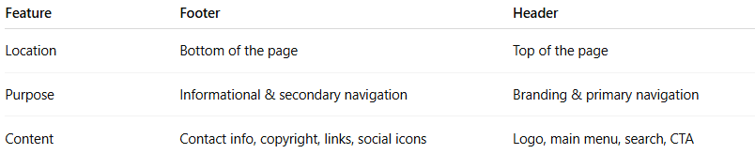
Feature | Footer | Header
Location | Bottom of the page | Top of the page
Purpose | Informational & secondary navigation | Branding & primary navigation
Content | Contact info, copyright, links, social icons | Logo, main menu, search, CTA

